2018 Change to Age Bands and Rate Formulas

Beginning in 2018, for the individual and small group markets, the ACA creates seven age bands and modifies the formulas used to set rates for enrollees who are under 21. Currently there is only one age band and one rate for those under 21. The new formulas are 20% to 53% higher than the current formulas. Due to this ACA mandated change, rates for enrollees under 21 (including dependents) may be subject to moderate to significant rate increases in 2018.

Why is this change happening?
According to the American Academy of Actuaries, “HHS is replacing the single age band with multiple child age bands to better reflect the actuarial risk of children and to provide a more gradual transition from child to adult age rating.”

What are the seven age bands create by the ACA for 2018?
In the individual and small group markets, seven age bands will exist in 2018 for subscribers ages 0-14, 15, 16, 17, 18, 19, and 20. Currently there is only one age band for those ages 0-20.

Who will be affected by the change?
As a result of the change in the age bands and formulas, there will be a 20-50 percent increase in the under-21 rates, depending on age. There may be a decrease in the rate of enrollees who are 21 and older. According to the American Academy of Actuaries, “because of the single risk pool and index rating requirements, the increase in child rates results in a decrease in adult rates, albeit of a significantly smaller magnitude.”
Those covered by grandfathered plans are not affected. Groups sitused outside of California may have a variation of the rate formula applied.

When will the change take effect?
The new age bands and formulas take effect January 1, 2018. Those securing new coverage in 2018 will be subject to the new rate formulas and for those already covered, the new formulas will apply at the contract renewal in 2018.

How much will rates change?
Table 1 below shows the new age bands, the new rate formulas (expressed as a ratio or percentage of the 21-year-old rate) and the percentage increase that individuals in the new age bands will experience.

Currently the rate for anyone in the 0-20 band is 63.5% of the 21-year-old rate. In 2018, there will be seven new age bands, each having a unique rate formula. All new ratios as a percentage of the 21-year-old premium are higher and may lead to rate increases. For example, currently, a 19 year old’s rate is 63.5% of a 21-year-old’s rate. In 2018, it will be 94.1%. This is a 48% increase. There is no change to either the age bands or the rate formulas for ages 21 and above.

(continued)

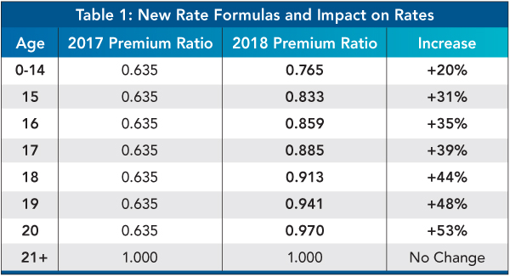

What will not change?
The following are not affected by the new under-21 age bands and formulas:
- The 3:1 ratio between the rate for a 64 year old and a 21 year old.
- All rate formulas are still based on the 21-year-old rate.
- No changes to age bands or formulas for those aged 21 and above.
- The fourth (and subsequent) dependent under 21 will continue be no cost.
- Dependent children age 21-25 will be rated individually based on age.

Example:
Below is an example of how the new age bands and formulas will impact one family considering new group coverage with an effective date of December 2017 versus January 2018. This example also illustrates how the carrier rate action may impact those over 21 (note the small decrease in the over-21 rate which the carrier made because they were able to rate the under 21 members more accurately).

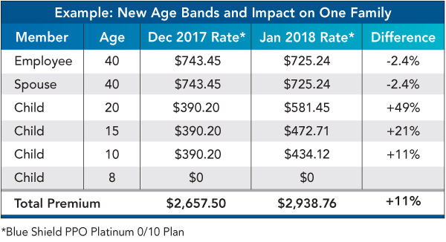

Resources
The Centers for Medicare and Medicaid Services published Guidance Regarding Age Curves and State Reporting for the benefit of each state and which specifies the new age bands and formulas.

