The Small Employer Healthcare Tax Credit
&
Covered California for Small Business

Quick Reference Guide for Business Owners and Managers

[Broker to customize with contact information as needed]

Small Employer Healthcare Tax Credit
Quick Reference Guide for Business Owners and Managers

The Big Picture

Purpose
Increase the number of individuals covered by medical insurance by making it more affordable for small employers, in lower wage businesses, to offer health insurance coverage.

To Qualify
An employer qualifies for the credit if it:
- Employs 2 or fewer full-time equivalent employees (FTE’s)
- Pays average wages of approximately $56,000 or less per FTE
- Purchases coverage through Covered California’s Small Business marketplace
- Tax-exempt businesses can also qualify

Full-time Equivalent Employee (FTE)
The IRS uses FTE to measure the number of full-time employees in a business when not everyone works full-time. For example, one 40-hour per week employee is counted as one FTE. Two 20-hour per week employees are also counted as one FTE.

The Tax Credit
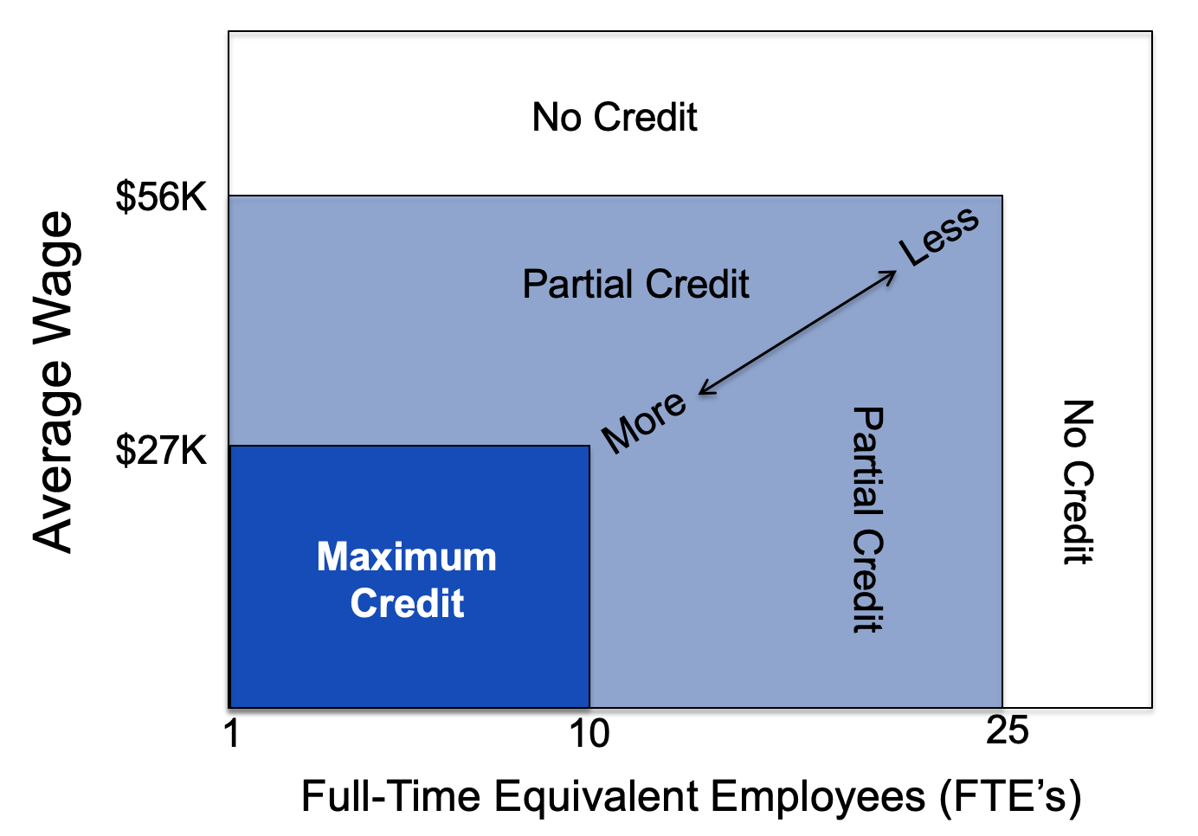
A tax credit is valuable – it is a dollar-for-dollar reduction in taxes owed by the business/owner. The tax credit is offered on a sliding scale with the maximum earned if a business has 10 or fewer FTE’s and pays approximately $27,000 or less in average wages. The credit phases out once a business has 25 or more FTE’s or approximately $56,000 or more in average wages.

For Profit Non-Profit
Maximum credit 50% 35%

The credit is based on the amount the employer contributes towards the employees’ premiums for medical coverage. Formula to calculate dollar value:

credit% x premium paid = dollar value of credit

An employer can apply for the credit for a maximum of two consecutive years. To apply, an employer’s tax advisor files Form 8941 together with the business return (or personal return if sole prop, partnership or S-corp), deducting the amount of the credit from the taxes owed. Unused credit can be applied toward tax liability in future years.

How We Can Help [Broker to customize]
Please contact me today to learn how you can lower the cost of your group medical plan. As a licensed insurance agent, certified with Covered California, I can help you evaluate the cost and benefits of securing group medical insurance and estimate the tax credit for which you might qualify. These services are provided at no cost to you.

The Details

Covered California for Small Business (CCSB) – is the marketplace where small employers can purchase coverage that qualifies them for the tax credit (if they meet the other eligibility requirements). When purchasing coverage through CCSB, the employer must cover at least 50% of the cost for employees (not dependents). This is common for all group insurance coverage.

Eligibility – Any business (taxable or tax-exempt) that meets the FTE count and average wage requirements is eligible for the tax credit. Since the credit is based on the amount of premium paid to CCSB, business owners can maximize the credit by enrolling in CCSB plans at the beginning of or early in their tax year.

Counting Premium, FTE’s & Average Wage
- The time period used is the employer’s tax year.
- Premium is the amount paid by the employer for employees’ “health insurance coverage” (defined below).
- Business owners and their relatives are excluded from all calculations.
- To count FTE’s add up total hours worked by all employees (max 2,080 hours per employee), divide by 2,080 and round down to nearest whole number.
- Seasonal employees are excluded from the FTE and wage counts, however if the employer pays for their coverage, that amount is included in the total premium paid.
- All employees who worked during the tax year are counted (minus the exceptions above) regardless if they are still employed.
- Control group rules apply – if an employer owns multiple businesses, the totals from all businesses are aggregated when calculating premium, FTE’s and average wage.

Health Insurance Coverage – includes typical small group medical, dental, vision, long-term care, hospital indemnity and Medicare supplemental plans. It excludes: accident-only, HRA’s, FSA’s, HSA’s.

Owners and relatives – A person is considered an owner if they are: an owner, a partner, a shareholder of more than 2% of an S corp or an owner of more than 5% of any other type of business. Relatives are: immediate relatives, spouses and in-laws of the owner.

Seasonal Employee – A seasonal employee is one that works less than 120 days during the year and whose employment is seasonal, such as a retail clerk who works only during the holiday season.

Household Employees – A sole proprietor must include household and other non-business employees when calculating FTE’s, average wages and premiums paid.

Business Deduction & Credit – The business deduction/expense for providing healthcare is reduced by the amount of the credit. The credit may be carried back one year and forward twenty years. Tax-exempt organizations apply the credit against 941 taxes owed.

Example – A for-profit employer pays $10,000 during the tax year towards medical coverage for employees. The employer qualifies for a 50% tax credit: 50% x $10,000 = $5,000. When the employer files tax returns at the end of the tax year, $5,000 can be deducted from the amount of tax owed.

Resources – The IRS web site has a section dedicated to the tax credit:

https://www.irs.gov/affordable-care-act/employers/small-business-health-care-tax-credit-and-the-shop-marketplace

[Broker to customize]
Contact SAMPLE INSURANCE AGENCY (http://www.SAMPLE.com) today to learn more about the advantages of the small business tax credit, establishing CCSB medical coverage, or switching to a CCSB plan if you already have coverage. If needed, we can also refer you to a tax advisor familiar with the tax credit. Call 000-000-0000 to get started.

Covered California for Small Business
Quick Reference Guide for Business Owners and Managers

About Covered California for Small Business (CCSB)
CCSB is the small employer division of Covered California, the state-run health insurance exchange mandated by the Affordable Care Act (Obamacare). Like the individual exchange run by Covered California, CCSB allows businesses to choose from a variety of standardized, affordable health plans and is the only place where a business can access the small employer tax credit.

Plans in CCSB
CCSB markets medical plans run by private insurance companies such as Blue Shield, Kaiser, Healthnet and others. CCSB is not a public insurance entity. When your business buys coverage through CCSB, employees are covered by private insurance companies just as they are when purchasing plans outside of CCSB.

CCSB plans are classified in easy to understand “metallic” levels:

Monthly % Expense % Expense
Cost Plan Covers Individual Covers
Bronze least 60% 40%
Silver moderate 70% 30%
Gold med-high 80% 20%
Platinum most 90% 10%

Features and Benefits
The benefits of CCSB for a small employer are:

- Employee choice – employees get to choose their medical plan. The employer picks up to four metal tiers they would like to offer and employees choose from any plan in those tiers. This relieves the employer of having to make the difficult choice of which plan is to offer employees.
- Tax credit – CCSB is the only place where an employer can qualify for the small business healthcare tax credit. Qualified employers could save as much as 50% through the tax credit.
- Competitive pricing/rate lock – CCSB worked with the insurance carriers to develop plans that are competitively priced for small business. Once plans are selected, prices are fixed for one year.
- Simplified administration – CCSB consolidates all billing and the employer receives one invoice even though employees may be covered by plans from different carriers.
- Standardized benefits – CCSB has worked carefully with the insurance companies to structure plans where the benefits are organized consistently. This makes it easier for employees to understand the plans and generates less questions for the employer.

Assistance [Broker to customize]
There are many aspects to starting a group benefits plan. It is not as simple as booking a plane ticket online, as many have claimed. As an experienced, certified, insurance agent I can help you evaluate and develop the best group benefits program for your company. I can advise you on the features and benefits of CCSB plans, and best of all, my services are provided to you at no cost.

The Details

Eligibility – to purchase coverage through CCSB, a business must:
- have at least one “W2” employee and no more than 50 employees
- If only one W2 employee, that person cannot be the owner’s spouse
- pay 50% or more towards employee-only coverage (dependent coverage not necessary)
- have at least 70% participation of employees in the plans
- offer coverage to full-time employees (those working 30 hours per week) and optionally to part-time employees (those working 20-30 hours per week). Seasonal and 1099 workers are not eligible.
- offer coverage to eligible employees within 90 days from hire date
- have a business based in California with at least one “W2” employee living in California
- a business can enroll at any time – no “open enrollment” period like the individual market

[Broker to customize]
Contact us today (http://www.SAMPLE.com) to learn more about the advantages of the small business tax credit, establishing CCSB medical coverage, or switching to a CCSB plan if you already have coverage. If needed, I can refer you to a tax advisor familiar with the tax credit. Call 000-000-0000 to get started.

Health Plans in CCSB

